Prices
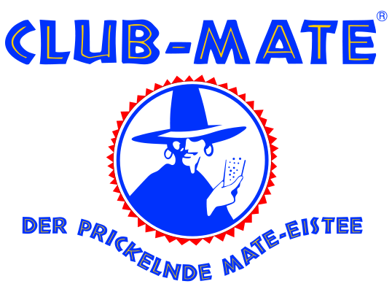 Club Mate 3.--
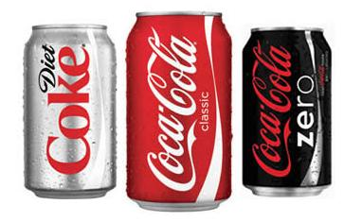
Soft drink 1.--
Coca-Cola, Ice Tea, Orangina, Bilz, Guarana, ultivitamin,choky …
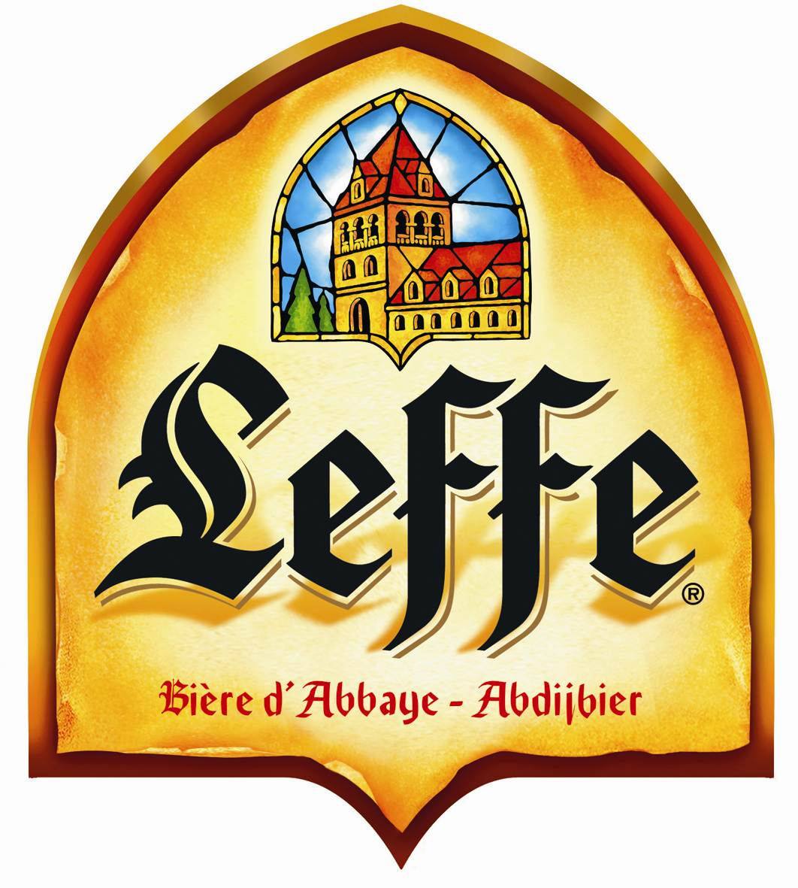 Leffe blonde 2.--
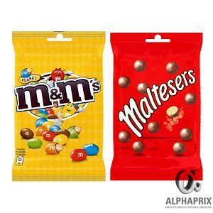
Snack 1.--
M&M's, Maltesers, Skittles,
Fishermans, Corny, Balisto, ...
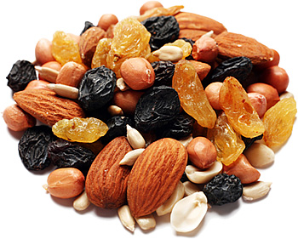
Fruits secs & Snacks 1.--
Ne pas jeter les assiettes. la pelle

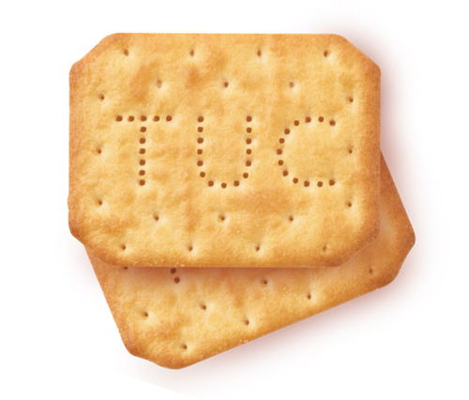
Tuc 2.--

