Prices
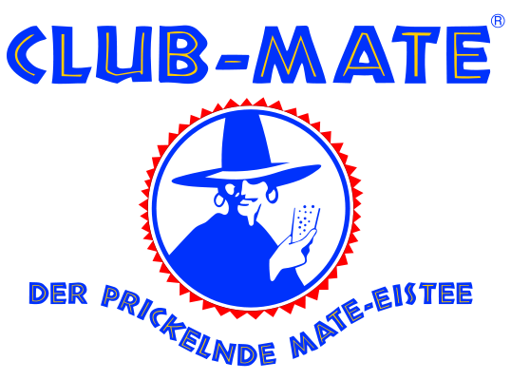
Club Mate 2.--

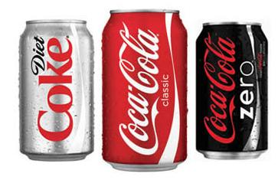
Soft drink 1.--
Coca-Cola, Ice Tea, Orangina, Bilz, Schweppes Agrum, Choky 0.25 L, ...
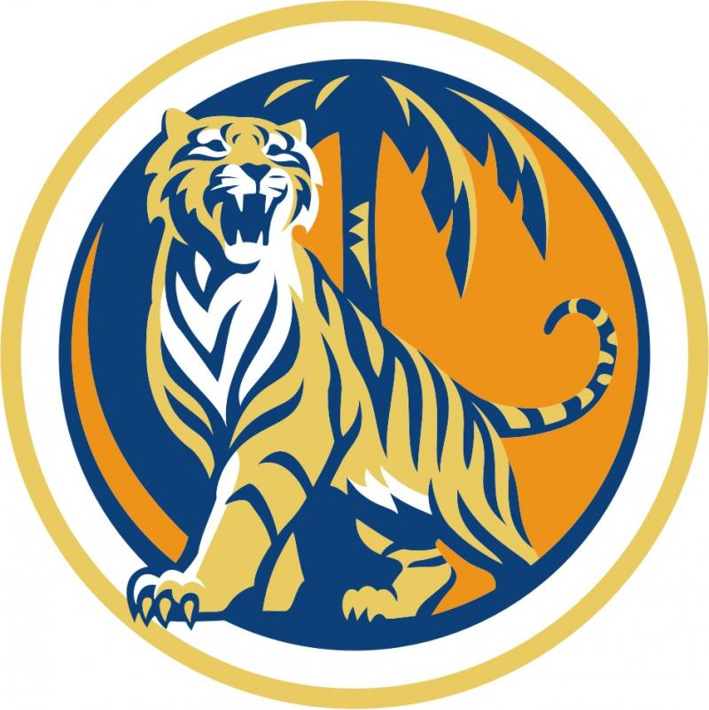
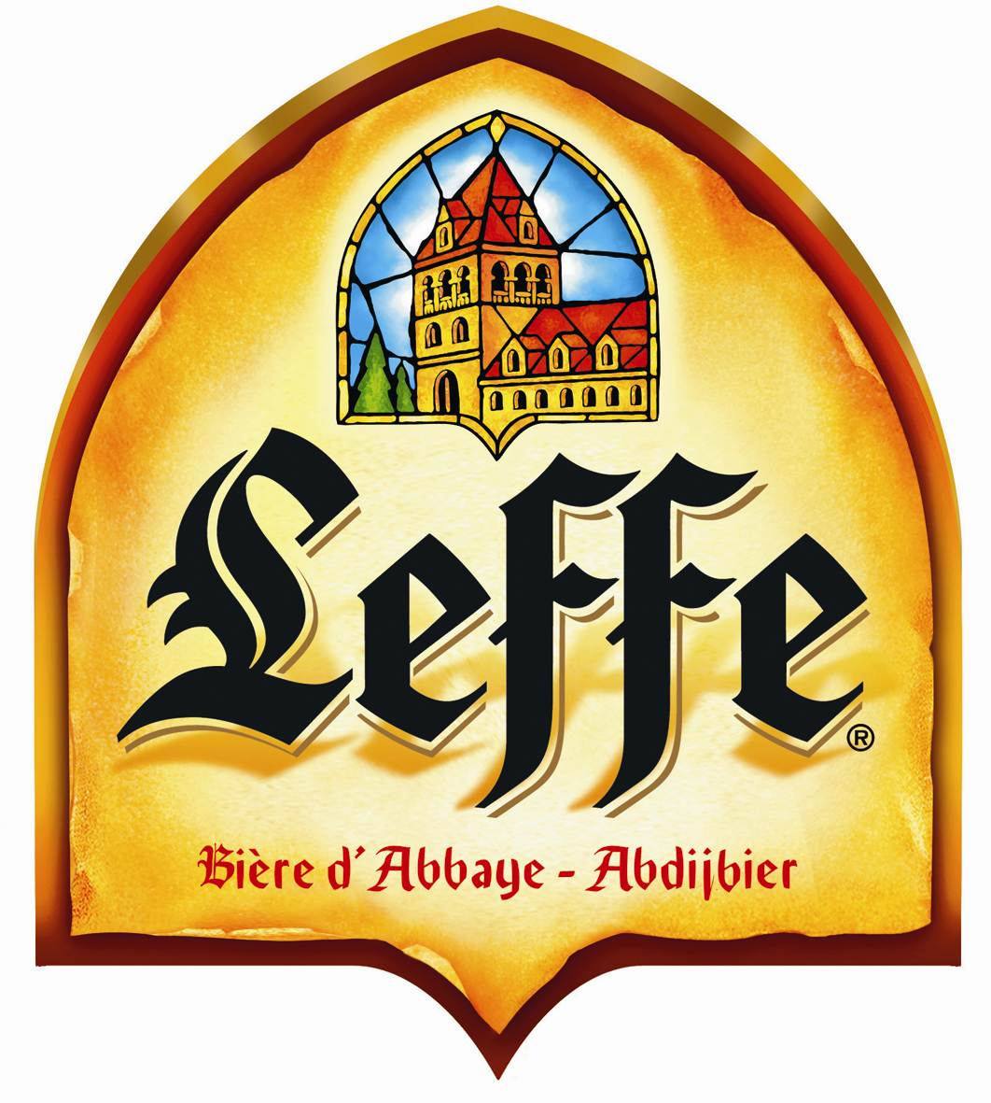
Beer 2.--

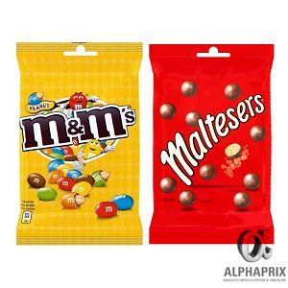
Snack 1.--
M&M's, Corny, Oreo, Chocoly,
Fishermans, Balisto, Chewing-gum, ...

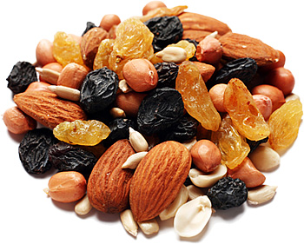
Snack-bar 1.--
Dried fruits, salted snacks the bowl
Do not throw the bowls! Wash them.
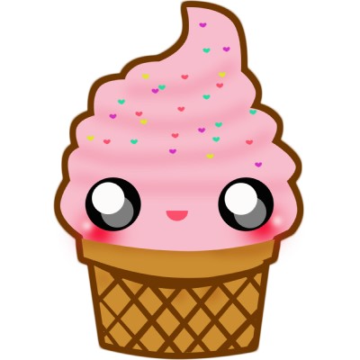
Ice Cream 1.--
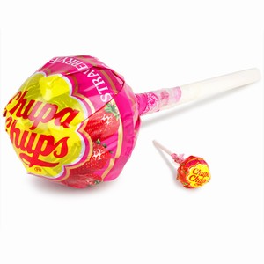
Chupa Chups 0.50
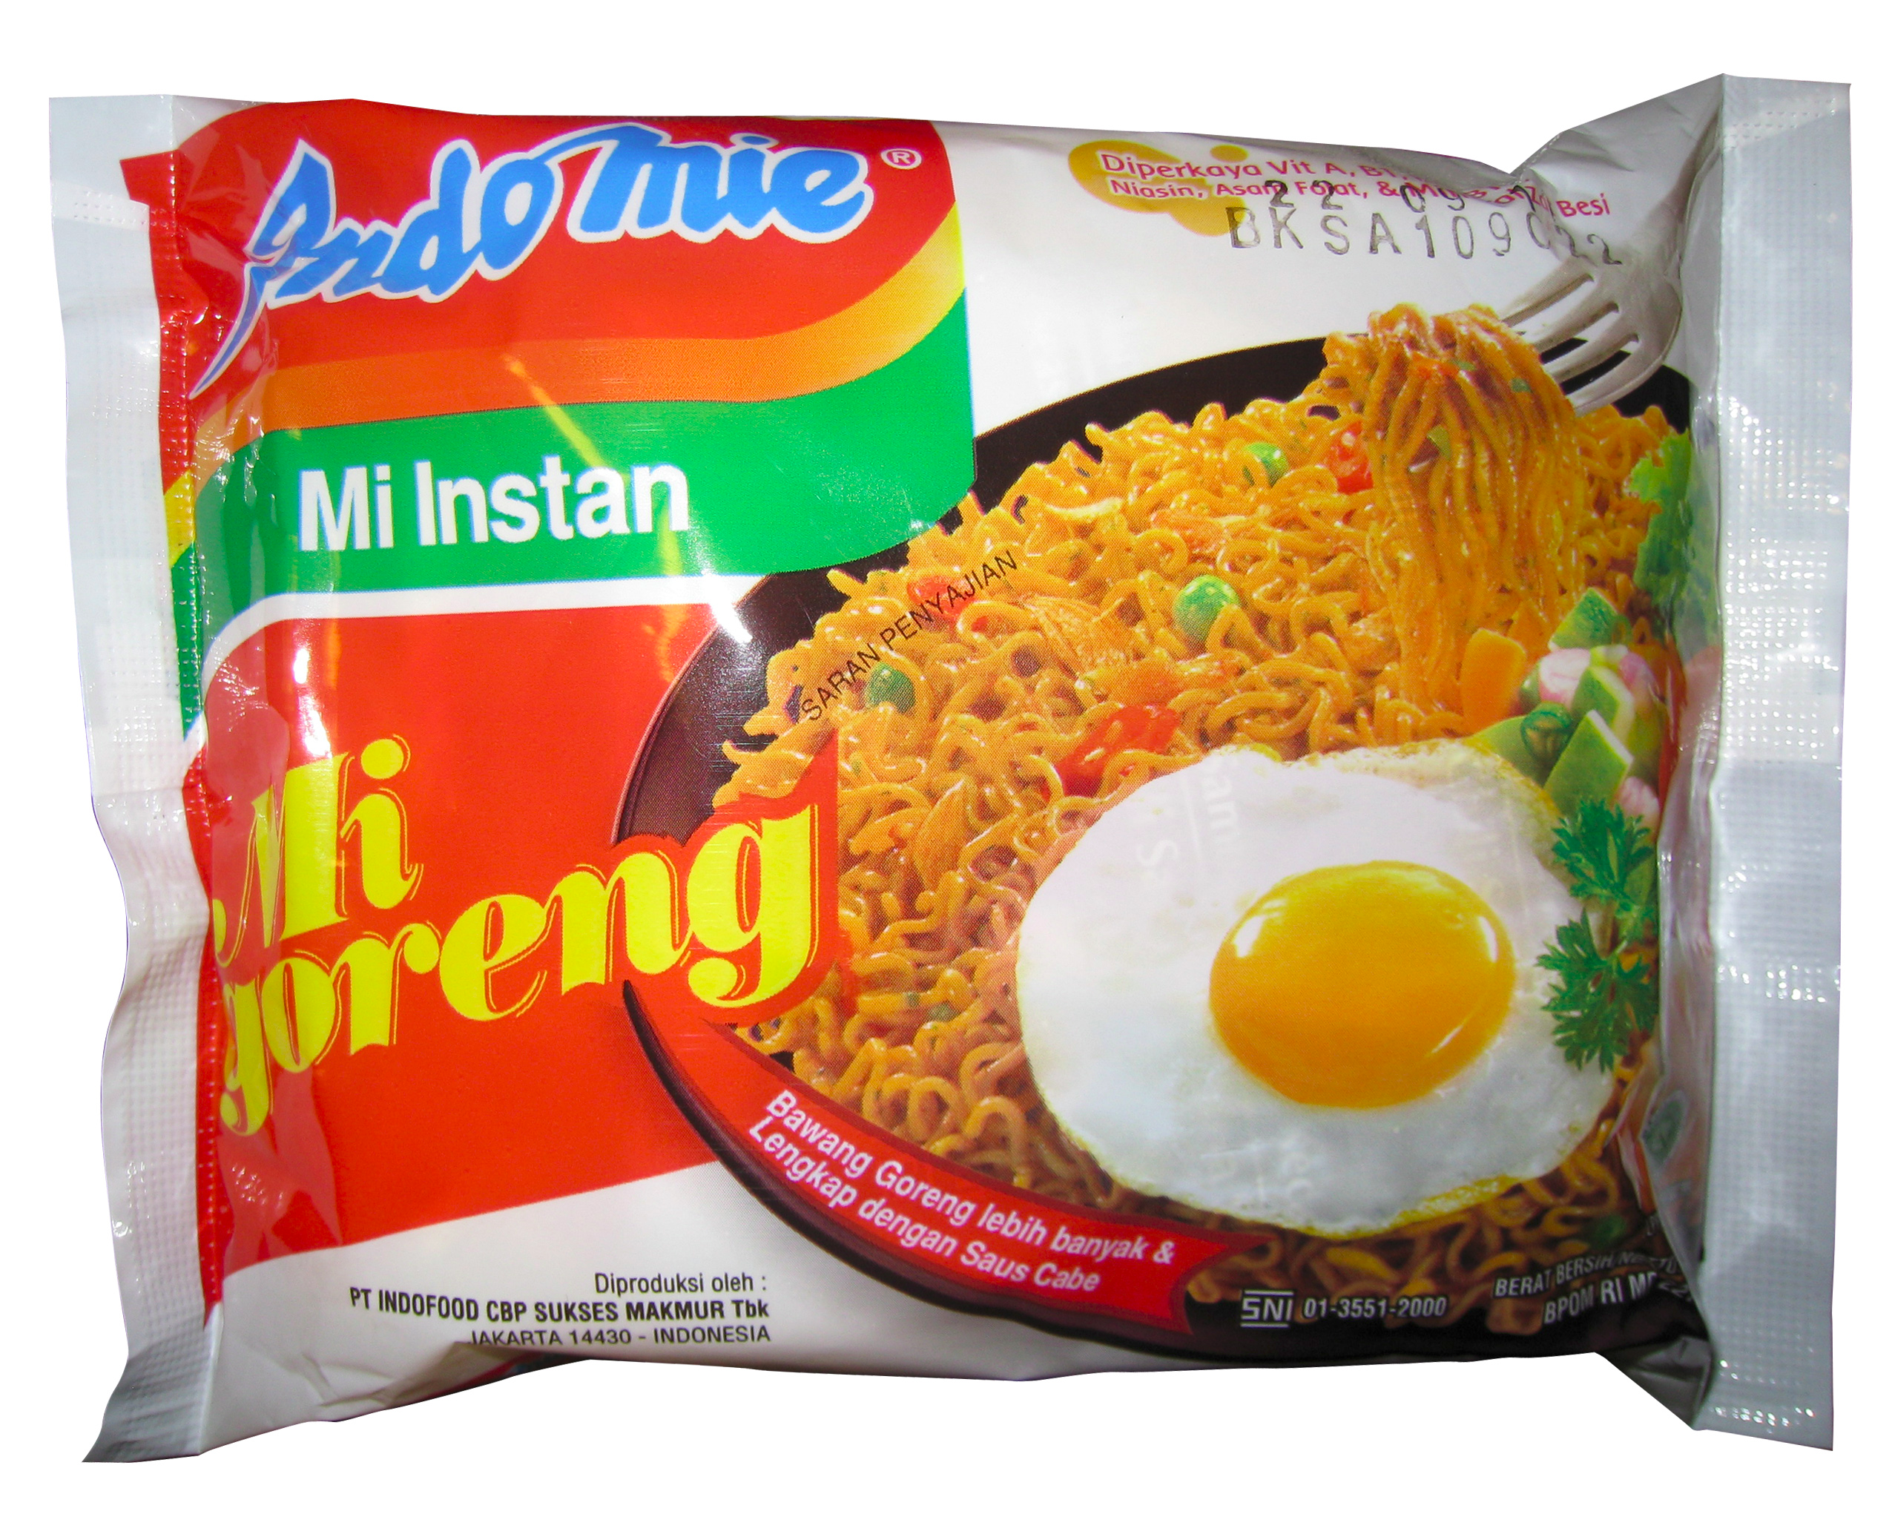
Instant noodles 1.50

